Assignment (N+) Day-6(Overview of Networking Devices)
Task-1:
Network Device | Main Functions in a Home Setup | Typical Physical Ports Used
Router | Connects the home network (LAN) to the internet (WAN), assigns local IP addresses (DHCP), and routes packets between networks using IP addresses. | 1 WAN (Internet) port and usually 4 LAN (Ethernet RJ-45) ports.
Switch | Connects multiple wired devices within the same local network, efficiently forwarding data only to the intended destination using MAC addresses. | 4, 8, 16, or 24+ Ethernet (RJ-45) ports.
Access Point (AP) | Broadcasts the Wi-Fi signal (SSID) to bridge wireless devices (phones, laptops) into the wired home network. | 1 Ethernet (RJ-45) port (often uses PoE to receive power and data via one cable).
Firewall | Inspects incoming and outgoing network traffic, blocking unauthorized access and threats based on security rules (typically built into home routers). | Physical WAN/LAN ports; filters logical TCP/UDP ports (e.g., blocking port 22 or 3389).
Hub | An older, obsolete device that connects wired devices but blindly broadcasts all received data to every port, causing network congestion. | 4 to 8 Ethernet (RJ-45) ports.

Task-2:

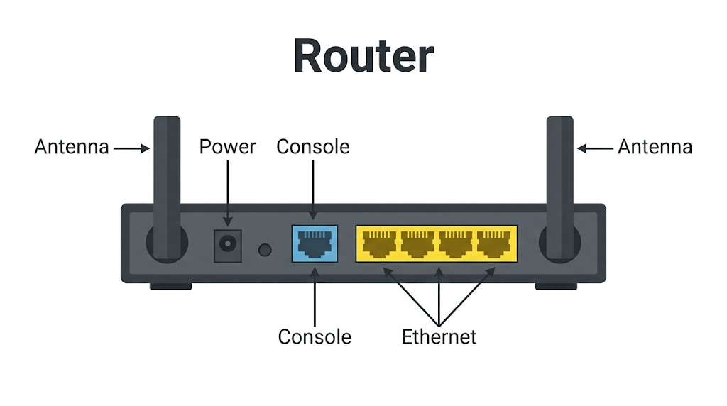
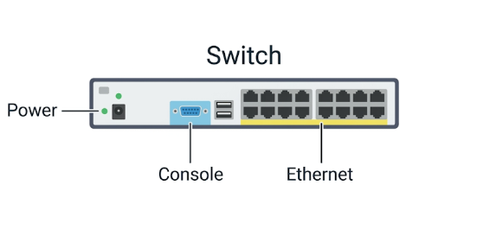
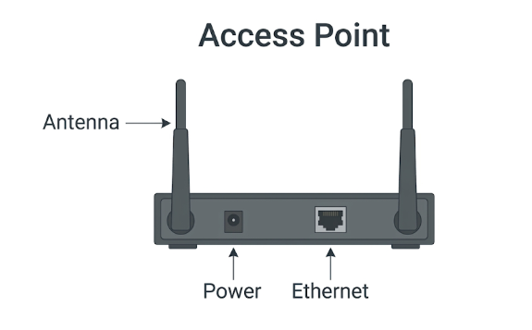
Task-3:
When you open Instagram to view photos, an Access Point first connects your wireless phone to your local home network. Next, your Router takes your photo request and directs it across the internet to find Instagram's servers. At the same time, a Firewall scans this traffic to block any hackers and ensure the data coming back to your phone is safe.

Task-4:
The most likely reason for the slow speed and disconnects is that a single Access Point is overloaded. When too many students connect their phones and laptops to one access point at the same time, it gets overwhelmed and starts dropping people to try and keep up.
Upgrading to a newer, high-capacity Access Point can easily fix this. Modern access points are built to handle hundreds of devices at once, which will clear up the wireless traffic jam, give everyone a much stronger signal, and stop the random disconnects.

